Web Server Lab Setup
- Table of content
- Apache
- php
- MySql
- phpMyAdmin
- LAMP Architecture
- L – Linux
- A – Apache
- M – MySql
- P – PHP

- Install Apache
- sudo apt insatll apache2 -y
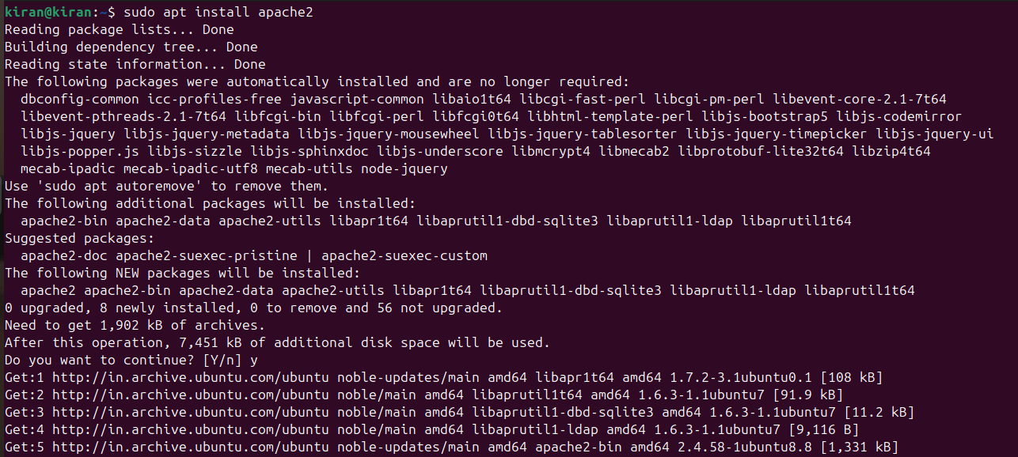
- sudo systemctl start apache2
- sudo systemctl enable apache2
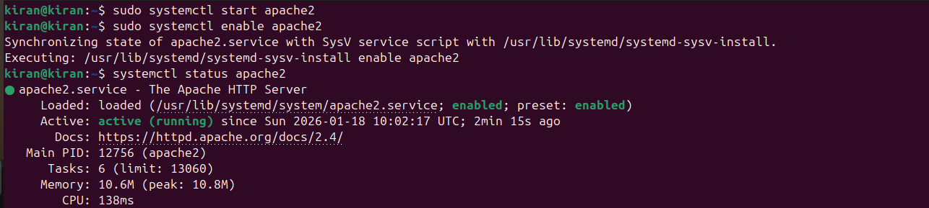
- systemctl status apache2

- Install php
- sudo apt insatll php –y
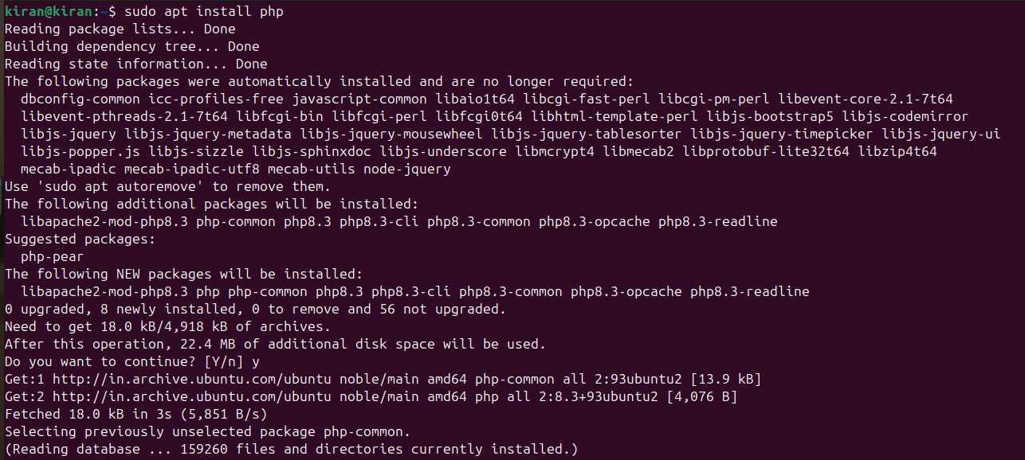

- Install MySql Server
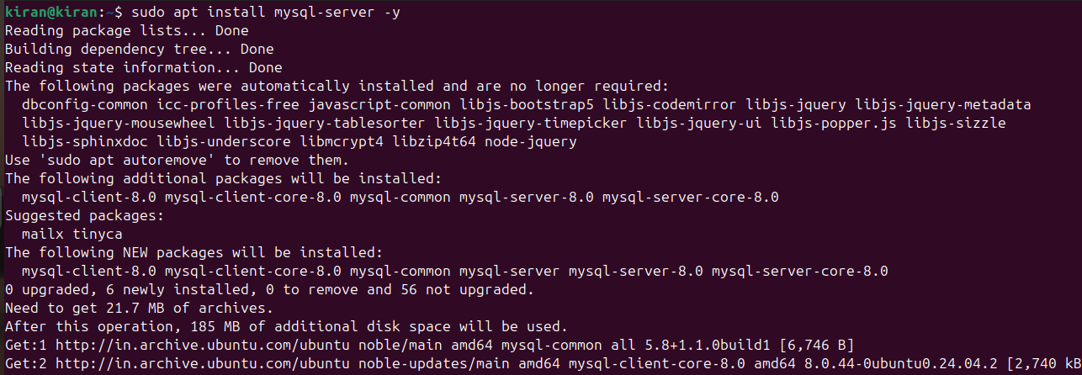
- sudo apt install mysql-server -y

- sudo systemctl start mysql
- sudo systemctl enable mysql
- sudo systemctl start mysql
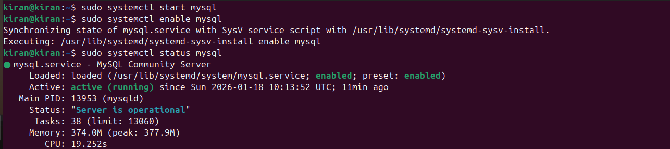

- To create a user for mysql service
- mysql -uroot
- CREATE USER ‘root’@’%’ IDENTIFIED BY ‘kiran@kk’;
- GRANT ALL PRIVILEGES ON *.* TO ‘root’@’%’;
- FLUSH PRIVILEGES;
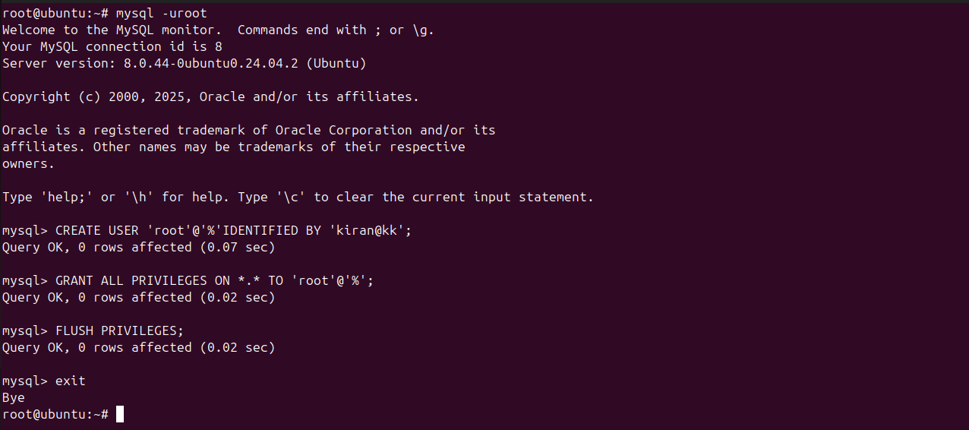

- Install phpMyAdmin
- sudo apt install phpmyadmin
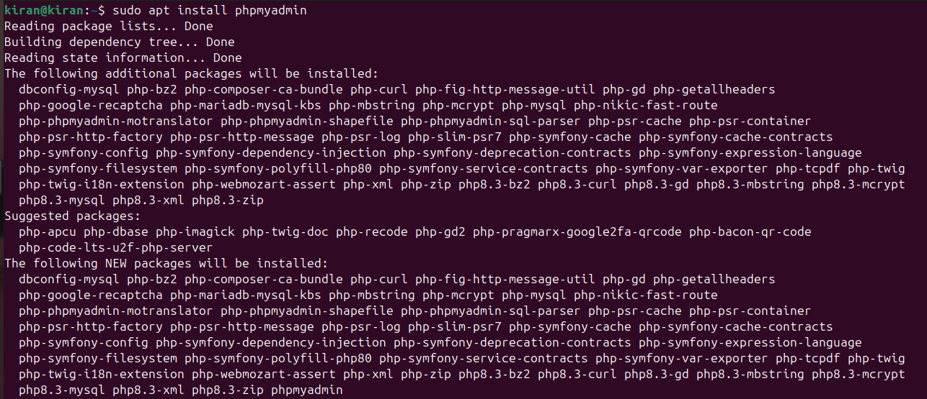
- cd /etc/apache2
- ls
- sudo nano apache2.conf
- Go to last and add
- #phpMyAdmin Configuration
- Include /etc/phpmyadmin/apache2.conf

- service apache2 restart

